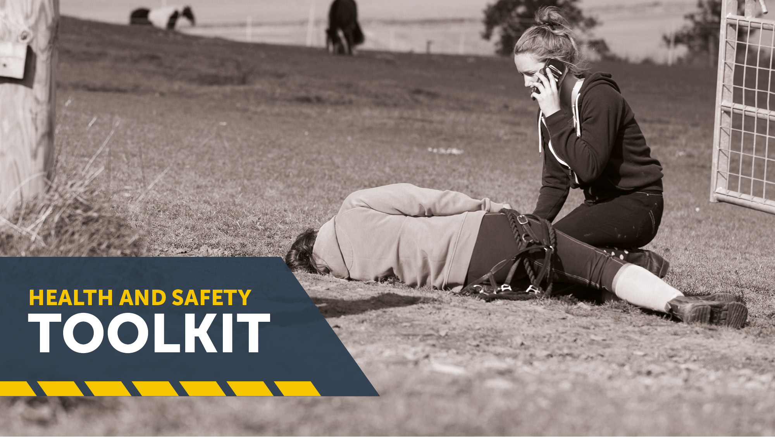
EEA Launches Health and Safety Toolkit

The Equestrian Employers Association (EEA) has announced the launch of an innovative online Health and Safety Toolkit.

This latest development comes as a response to several requests from EEA members, who were unable to find equestrian specific health and safety guidance elsewhere for their yards.

Now employers can create a bespoke Health and Safety Manual which outlines the way in which safety will be managed for employees and customers within their equestrian business; and by using the Risk Assessment Creator, create a series of personalised documents which identify how to keep people safe.

With the addition of equestrian specific case studies and practical advice on how to make the work place compliant, employers now have an easy solution to their business health and safety needs.
Tullis Matson, President of the EEA said,

“In any equestrian workplace, the many different hazards that workers are exposed to daily can lead to incidents at work. The employer has a responsibility to provide as safe a working environment as possible and to have procedures in place to reduce the risk of injuries or damage to health.

Violating or not having the correct health and safety practices in place could have a tremendous and costly impact on your business.”

The Health and Safety Toolkit is part of the comprehensive employment support provided to members of the EEA as an inclusive benefit of membership.

Visit https://equestrianemployers.org.uk/safeworkplace
___________________________________________________________________
Notes:

The Equestrian Employers Association offers a complete employment toolkit especially tailored to the equestrian industry and includes the Contract Creator, staff handbook creator, free downloads, legal documents, advice and access to the Pensions and Payroll.

Enquiries to:
Liz Daniels, Email: liz.daniels@britishgrooms.org.uk; Tel: 07779 318044

