Registered User (coach,mentor,etc.)

Sign up
- Go to https://horsescotland.beezer.com/sign-up
- Fill in your details, select as a Registered User, and Sign up.

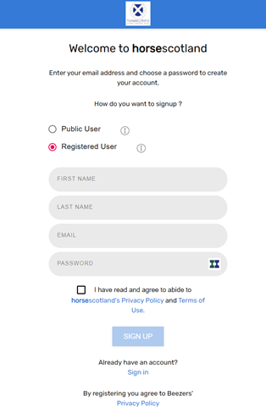

- Follow the instructions to verify your email address. You will receive an email (see below) with verification from membersupport@horsescotland.com

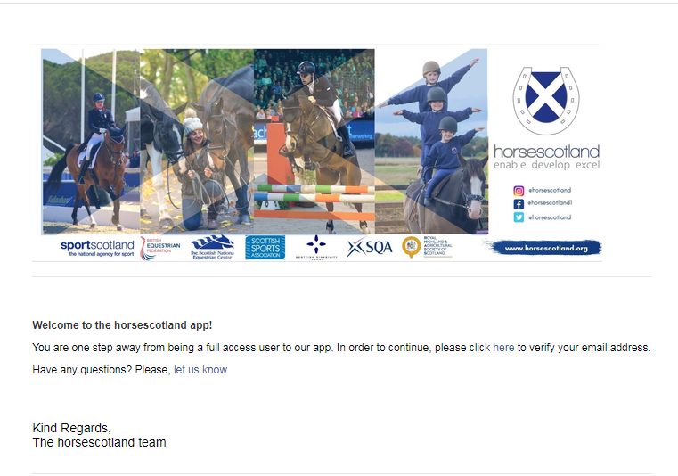

Your personal profile

- Go to your user profile, which is located in the top right corner menu of the app. (select the ⋮ menu at the top right corner) and click ‘Profile’

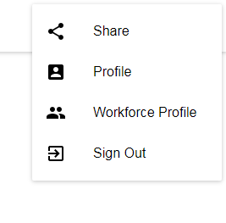
- You can also complete your personal profile by clicking on “Complete your personal profile” within the workforce profile area (see below)

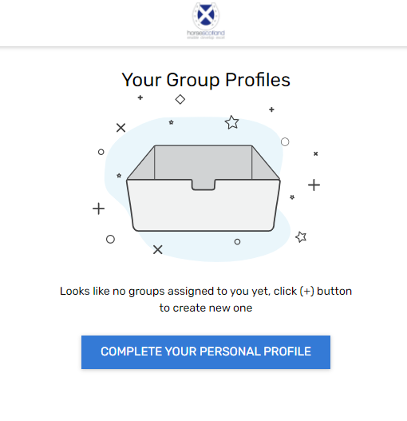
Complete the information below:
- Personal info
- Address info
- Social info

Your Registered User profile

- Go to your Workforce profile, which is located in the top right corner menu of the app. (select the ⋮ menu at the top right corner) and click ‘Workforce Profile’
- Click the green + to add a group profile (please note, you can be part of several groups)

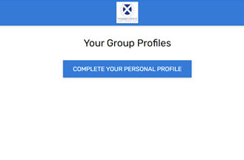

- Click on ‘Choose a Group’ and enter required information

- To complete the profile, click on the Group and enter required information

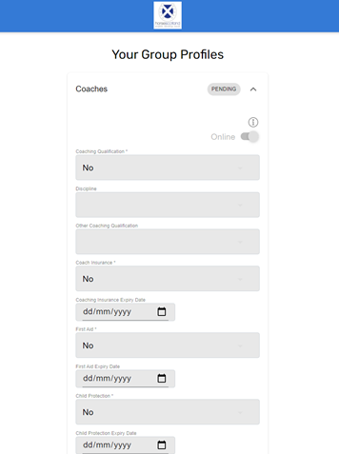
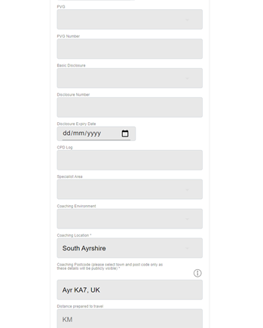
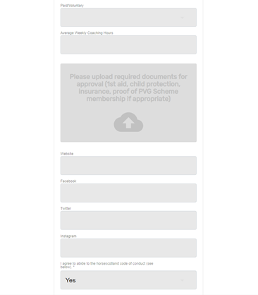
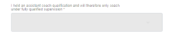
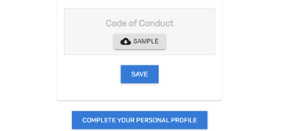

- Download and read our Code of Conduct (click ‘SAMPLE’) then answer ‘Yes’ to ‘I agree to abide to the horsescotland code of conduct. All workforce members must agree to our code of conduct to be part of our coaches register.

- Please ensure you answer ‘Yes’ or ‘No’ in the final field which states ‘I hold an assistant coach qualification and will therefore only coach under fully qualified supervision’ All Level 1 (Assistant) coaches must confirm that they are only coaching under supervision to be part of our coaches register.

- DON’T FORGET TO CLICK SAVE!

- A member of horsescotland will review your application to the specific workforce group. Once they approve it you will receive an email to confirm that it has been approved and your profile will be displayed on our App here: https://horsescotland.beezer.com/find-a-community-membercoachmentoretc
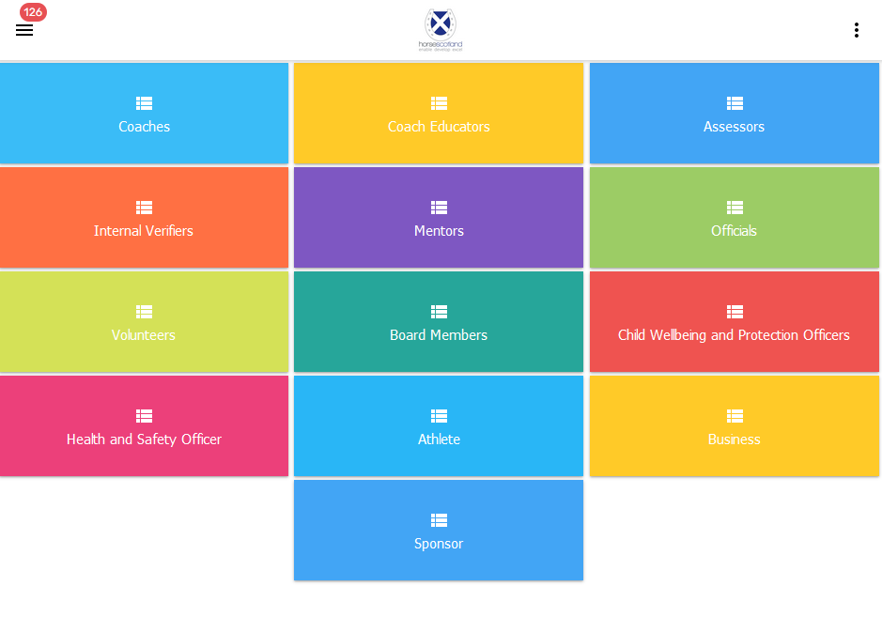
- App users will then be able to find your profile. They will also be able to contact you by completing a form which will be sent to your email address.

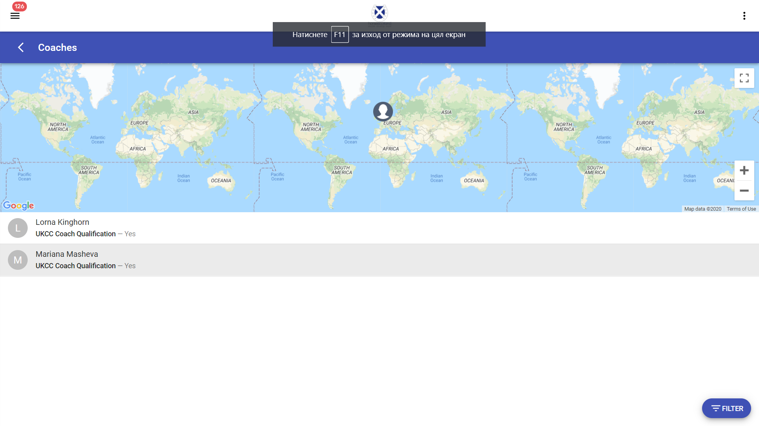
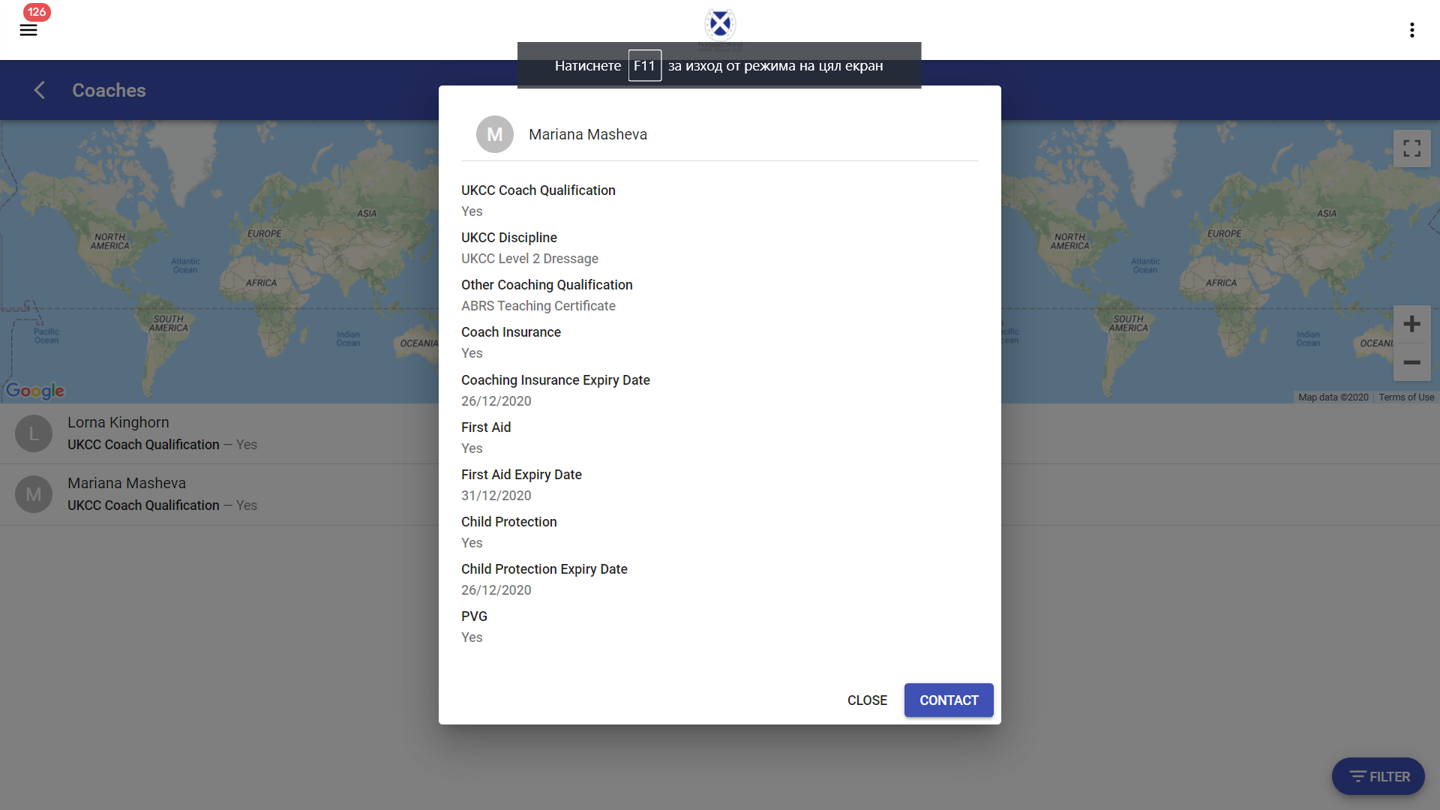

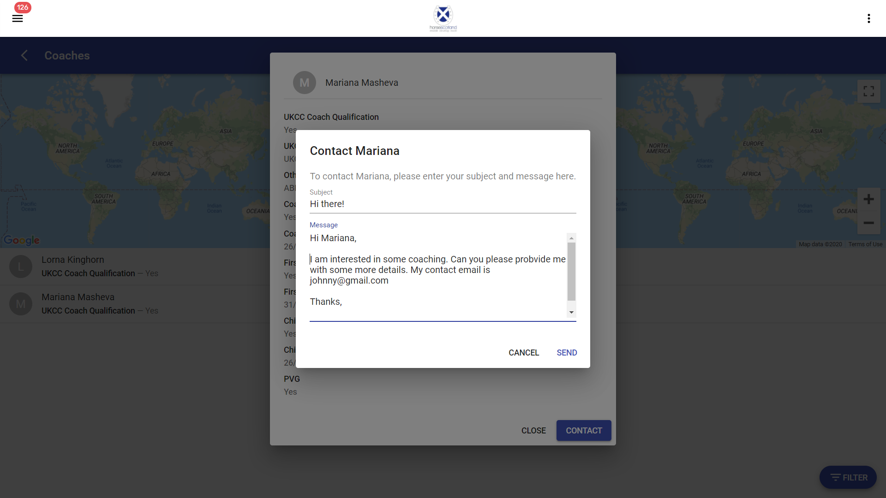

Edit a Workforce Group profile
- You can always go back to the Workforce profile and edit any of the fields including First aid expiry date and other important information that might need to be updated over time.
- Every time you upload a new document to your Workforce Group profile, it will be sent for review by the horsescotland app admin, and your Group status will be shown as Pending.
- You will receive an email confirmation after the horsescotland app admin has approved your changes to the workforce group profile and the status will be changed to Active.

Using the app as an end user
As a Registered User you will also be able to use the app as a regular end user. You will be able to access all pages in the app: https://horsescotland.beezer.com/

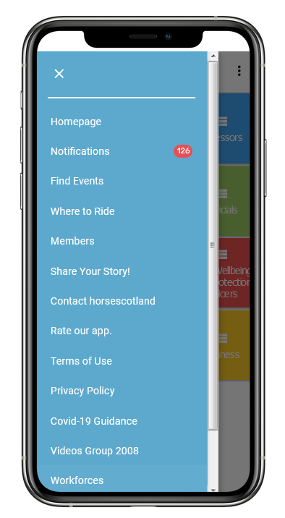

How to install the horsescotland app on your device

- To install the app on your device, please visit this link https://horsescotland.beezer.com/ from your mobile device
- You will be asked to install the app by clicking the banner popup at the bottom of the screen.
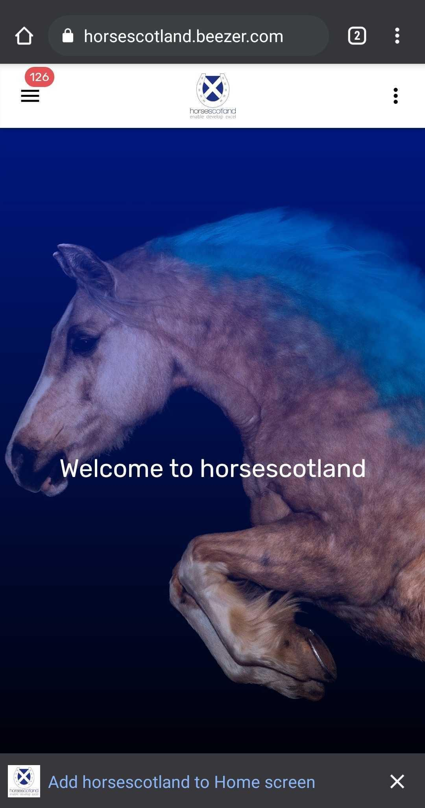

- After clicking the 'Add to Home screen' link you then press add. (If you have dismissed the prompt you can add manually by choosing Add to Home Screen from the Settings menu of the browser).
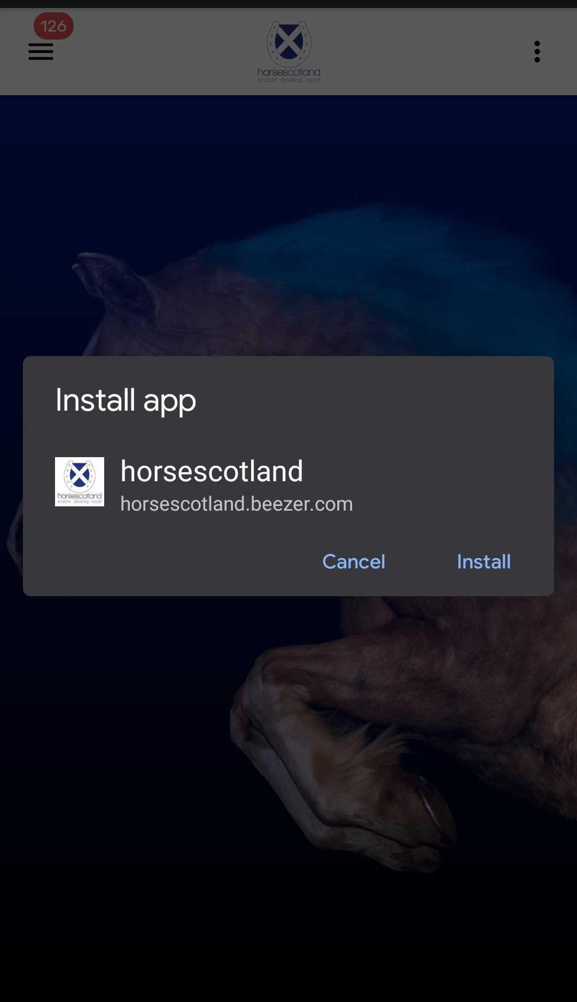
App is installed to the Home Screen and a dot will appear showing new notifications have been sent.
