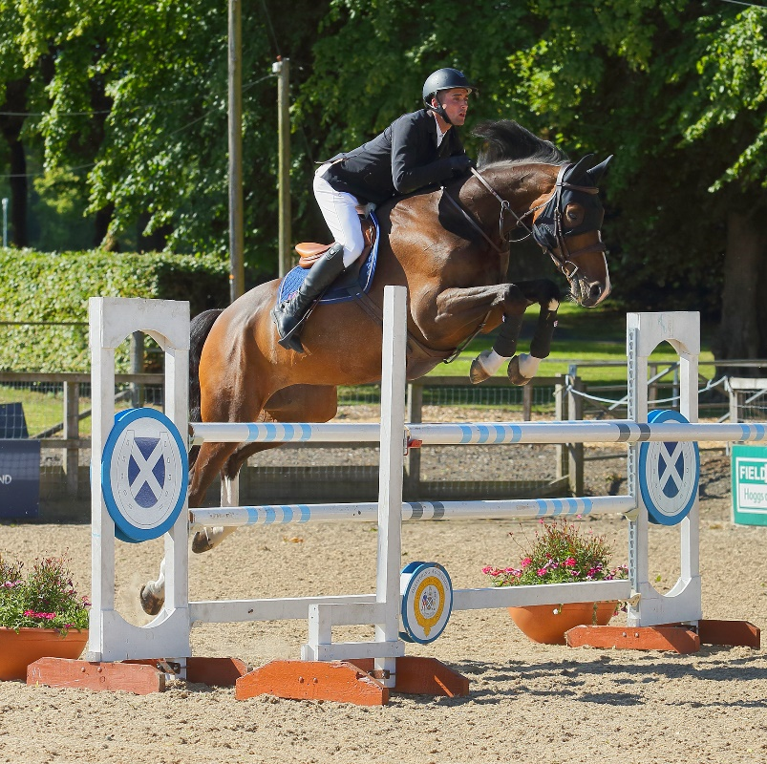
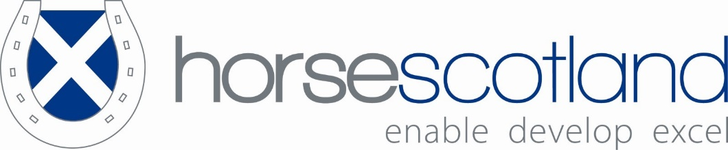
Performance and Talent Pathway Handbook

Foreword

As the governing body for equestrianism, horsescotland represents the horse and the equestrian industry. Growing participation is a main pillar of the organisation’s strategy as we look to encourage all individuals to be involved with the horse, from grassroots to elite competition. Involvement comes in many forms as a rider, groom, owner, enthusiast or supporting practitioner and the horsescotland strategy aims to inspire all these individuals to be a part of the equestrian world.

The Performance and Talent Pathway seeks to develop this involvement with the equestrian world, through a clearly defined path for riders, beginning with talent identification and leading to entering the British Equestrian World Class Pathway. Our new Talent Advisors within each Olympic discipline will broaden the reach horsescotland has at grassroots level, enabling talent to be identified earlier so the Pathway can nurture these athletes and equines earlier in their journey. A range of education is offered off-the-horse, with the online learning platform that delivers training on-horse and human fitness, business management and communication. This rounded offering is designed to develop our athletes so they will have a long-term and sustainable business model.

Maintaining our rider’s ability to perform on a world stage, ensures that the equine remains in the public eye, inspiring new individuals to become part of the sport, whilst ensuring those working within the industry continue to have a sustainable future.

Richard Johnston-Smith
horsescotland Performance Director

Introduction to horsescotland
horsescotland works collectively with its Member Bodies to ensure future development by striving to increase the level of sustainable resources, investment and support.

horsescotland is committed to the empowerment of its Member Bodies, and their respective members, through establishing and bolstering reciprocal communications.

horsescotland is committed to increasing accessibility to equestrian activity and widening the opportunities for greater participation.

Our Vision
We aspire to empower Scotland to be a leading, inclusive nation for horse sports and activities.

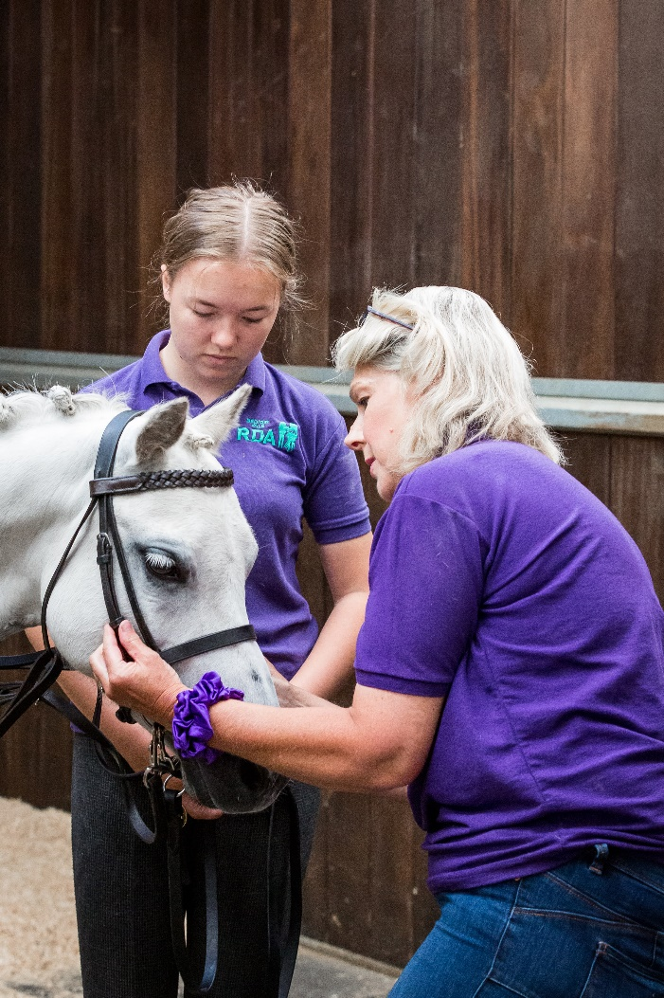

Our Mission
- To connect the Scottish equestrian community
- To collaborate with partner organisations
and government
- To enable people, horses and places to prosper

horsescotland Values
- Equality and Inclusion
- Widening access for participation
- Respect for the environment
- Securing pathways for progression at all levels
- Enthusiasm, fun, pleasure from Equine activity
- Teamwork and collaborative development
at all levels
- Celebrate success
- Financial Sustainability

Pathway Background and objectives
The horsescotland Performance Pathway is supported by National Lottery funding from sportscotland, with the aims of supporting athletes and equines:

- securing places on GB teams
And/or
- British Equestrian World Class Podium Programmes

There are two pathways within the Performance Pathway defined by the criteria, as agreed with each Olympic Discipline and can be found in the Performance Handbook. Our pathway is designed to develop the potential of equine and athlete in a performance environment through our Talent Pathway and Performance Pathway to achieve their individualise agreed goals.

Duration of Pathway
Formal selection takes place every two years. Selected athletes can remain on the pathway subject to successful re-selection. Athletes are expected to reach their set goals based on their annual plan and can remain on the pathway as follows:

Talent Programme – an athlete can be on the programme for two cycles of two years, in exceptional circumstances where goals are exceeded or there is benefit to the athlete an extension may be granted as agreed with the Performance Director and Pathway team
Performance Programme – an athlete can be on the programme for two cycles of two years, in exceptional circumstances where goals are exceeded or there is benefit to the athlete an extension may be granted as agreed with the Performance Director and Pathway team

An athlete can complete two cycles on the Talent pathway and two cycles on the Performance Pathway consecutively, meaning they can be part of the programme for 8 years.

Performance Pathway Values
The horsescotland pathway values follow those set out by the British Equestrian World Class Programme to allow us to instil these values from an early stage in the athlete’s day to behaviours.

Honesty  Openness  Courage | Benevolence  Care  Inclusion | Professionalism  Pride  Passion

The pathway seeks to develop Scottish athletes and equine partners in their chosen sport and to build a sustainable business model to enable their continued participation within the equestrian industry whilst competing. Through the online learning platform athletes can access support on a variety of equine, human and business areas which seeks to grow the Winning Attributes set out in the BEF Youth Development & Performance Pathway Handbook.

What it takes to win – Winning attributes
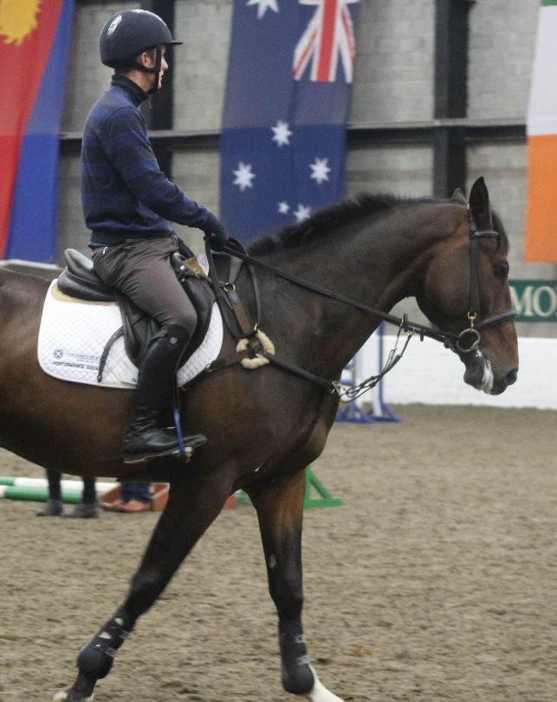
Access to horsepower capable of top results on the world stage
The right personal characteristics
Finance or a business to facilitate their campaign and performance plan, in order to develop current and future horsepower
Optimal logistical and performance support and major championship and qualifying internationals
Physical robustness and fitness, in addition to their horsepower also being so

Optimal support for both human and horse in their home training environment
Regular access to world class coaches
The support of owners and sponsors to enable them to purchase and retain horsepower

Selection Policy Objective
The specific aim of the selection policy is to outline the criteria and process for selection.

Selection Panel
The horsescotland board will appoint selectors to ensure that applicants meet the criteria and the ability to participate on the pathway. All selectors are appointed on the basis of expert knowledge and are contracted to comply with horsescotland’s code of conduct. The chair of the selection panel will be the horsescotland appointed Performance Director. The Performance Director will liaise with the equestrian Olympic disciplines in relation to the performance pathway and the selection process. The horsescotland Board will ratify the selection panel decisions.

Process of Selection

This will be managed by the horsescotland Performance Director in agreement and consultation with the respective Olympic disciplines. These disciplines must be members of horsescotland.

Stages of Selection

Stage 1: Application
Applicants are required to complete a formal horsescotland application form. It is the applicant’s responsibility to record electronic submission of application. Late or incomplete applications will not be accepted.

Stage 2: Shortlisting from Applications
Athletes are expected to reach the minimum criteria for their discipline (and age group) as outlined in this document. Whilst an athlete may meet the minimum criteria, they are not assured a place on the pathway. An offer of a place on the pathway will be based on the strength of the application and ridden assessment.

Stage 3: Ridden Assessment Day
Shortlisted athletes will attend an Assessment Day and will be required to undertake a practical ridden assessment for their identified discipline. Athletes will also take part in a formal interview and off the horse assessment. An independent verifier will be present during the assessment day to ensure the process is being delivered in a fair and consistent manner. While there is no fee to attend the ridden assessment day all expenses incurred will be the responsibility of the athlete.

Stage 4 Feedback from Ridden Assessment Day
All athletes will be informed as soon as possible following the Ridden Assessment Day whether or not they have been successful. The selectors’ reasoning for their selections is not discussed with athletes, owners or agents.

Stage 5: Induction Day and Formal Offer
Selected athletes will attend an Induction Day and will work with Coaches and Support staff to agree identified goals and confirm their commitment to the Performance Pathway by signing the formal offer.

Eligibility / Availability for Consideration
The minimum age on first application will normally be 16 years. An athlete’s age will be based on F.E.I. ruling, which is the age the athlete becomes in a given year. The calendar age is taken from the beginning of a calendar year that an athlete’s age is reached until the end of a calendar year that a athlete’s age is reached. Please visit the FEI website for further details http://www.fei.org/

Minimum Criteria
For all disciplines outlined, the competition results must have been obtained in the 12 months prior to the horsescotland selection process unless specifically stated otherwise. All results/ scores should be able to be verified by the appropriate Member Body database. If scores cannot be verified then the athlete will be responsible for supplying the evidence of the scores.
Please note any other requirements can be found under each discipline specific minimum criteria in Appendices A – D.

Confidentiality
It is vitally important for the integrity of the Selection Policy and those involved in its application both as athletes, owners, selectors or other officials, that there is at all times a high degree of confidentiality relating to information that may have a bearing on selection. Subsequently, the panel will keep all information relating to individual applicants confidential.

Athlete Obligations Once Selected
- Sign and adhere to the Pathway Contract and Code of Conduct
- Attend all training dates, unless otherwise agreed, and to fully engage with all aspects of training sessions
- Be proactive in their improvement of skills and personal in all areas development
- Commit to setting and achieving agreed goals based upon annual plan and action points
- Identify themselves as ambassadors for horsescotland, their member body and equestrianism as a whole
- Ensure that the highest possible animal welfare standards are maintain both in equine care and training methods
- Comply with I with anti-doping control rules, regulations and procedures as outlined in the WADA Code. The Prohibited List identifies which substances and methods are prohibited at all time, in competition only and within specific equestrian disciplines.

Changes in Policy
The Performance Director in consultation with horsescotland personnel will have the right to amend or change selection policies where necessary at any time in order to fulfil the objectives of the Selection Policy, as long as these changes and amendments are clearly communicated to all parties.

Force Majeure
For reasons beyond the horsescotland’s control (e.g. disease outbreak in equines or humans, war or terrorism) the Performance Director reserves the right to make the decision to change the selection policy or procedure, which might include cancellation of the Selection process or pathway. This decision will be made in consultation with the Olympic Discipline Member Body and the horsescotland Board.

Pathway Funding
Performance pathways are supported by funding from National Lottery through sportscotland (and others). Changes to funding may result in adjustment/cancellation of the pathway.

Midcycle applications
Applications may be made through member body during a two year cycle and should be supported by the Talent Advisor for the appropriate discipline, where an athlete and equine meet the Pathway criteria. Horsescotland reserve the right to invite athletes to attend an interview and an assessment day with the pathway coaches to ensure a fair assessment prior to selection outcome, in line with Stages 2 to 5 above.

Consultation
This selection and recruitment policy is formulated in agreement and in consultation with each respective Olympic Discipline Member Body.

Publication/ Circulation
The Selection Policy will be available on the horsescotland website.

Applications for Selection
An application form is available to download from the horsescotland websites. The closing date for applications will be published on the horsescotland website. References may be included to support your application if you wish to do so but must be submitted with the application form. Applications should be submitted electronically.

Enquiries
Enquiries about the Selection Policy should be made in writing to the horsescotland at performance@horsescotland.org

De-Selection Process
The annual plan and goals as agreed with the athlete, combined with achievements will form an on-going assessment for continued participation on the pathway. The Performance Director will record athlete and equine participation, development, and performance in conjunction with the athlete. In the event of poor participation, development and performance the Performance Director will consult with the athlete and the pathway personnel to identify any additional support required.

Reasons for De-Selection
- Continual failure to achieve agreed participation, development and performance goals as outlined in the annual plan will be considered a just reason for de-selection
- Horse / pony becoming unsuitable for any reason including loss of performance, ability, prolonged illness or lameness. Athletes will have three months unless otherwise agreed with the Performance Director to get the horse / pony back to its level of performance or find another horse / pony that they can achieve the performance level
- Loss of performance as an athlete through prolonged illness or injury will be discussed with the performance director and dealt with on a case by case basis dependent on Medical advice.
- Failure, without full justification, to compete in any named target competitions
- Failure, without full justification to attend or participate in all aspects of the Performance pathway
- Breach of contract / code of conduct
- Breach of rules, including anti-doping violation or other reasons that bring the sports into disrepute
- Failure to maintain high standards of equine welfare including care and training methods

De-Selection Procedure
Athletes must meet one or more of reasons for de-selection as set out above. In the first instance, the horsescotland Performance Director will speak to the Athlete and advise of the concerns. Thereafter written confirmation of the discussion will be provided including an agreed course of action, horsescotland reserve the right to share this information with your Olympic Discipline. De-selection will be determined by the Performance Director and Pathway team and athlete will be notified in writing following receipt of a report being submitted to the horsescotland Board. The athlete will receive a copy of the complaints / grievance policy if they wish to challenge the de-selection

Points of Contact
The key point of contact relating to this Selection Policy is the Performance Director via performance@horsescotland.org

Appeals Process and Procedures
Athletes have the right to appeal against the decision regarding selection or de-selection but only on the grounds that the Selectors have failed to comply with the Policy. Appeals must be made in writing to the Performance Director via e-mail to Performance@horsescotland.org within 48 hours of the announcements. If the Performance Director is not able to satisfy the appellant’s concerns the appeal will be forwarded to the horsescotland Board.

Appendix A
[This appendix must be read in conjunction with the body of the selection policy]
Dressage Criteria
All athletes must be eligible to compete for Great Britain and hold a current British passport. To be eligible for the pathway they must become full competing members of British Dressage on selection and reside in Scotland. Athletes will not be eligible for this pathway if they are currently supported by the BEF World Class Programme. Athletes that are currently serving a ban from competition as a result of a doping offence (equine or human) or equine medication offence will not be eligible.
U18 years
- Minimum of two final scores at 67% at Advanced Medium Silver/Gold and above (including FEI Junior Team and Individual Tests) at High Profile, Premier Leagues or BD National Championships
- Min. of two final scores of 67%+ in FEI Junior Team or Individual Test at CDI3* / CDIO3* / CDIYR or above (one score must come from Jnr Team test).
- Top 30 individual placing with a score over 65% at Junior European Championships in 2018

A minimum of 2 recent score sheets at the above level/s should accompany the application

U21 years
- Combinations will be competing consistently and achieving a minimum of two final scores of 67% or above at PSG/Inter 1 (incl. YR Team and Individual tests) achieved at High Profile/Premier Leagues, Regional Championships or BD National Championships
- Minimum of two final scores at 66% at PSG level and above (including FEI Young Rider Team and Individual Tests) in CDI/CDIJ
- Top 30 individual placing with a score over 65% at Young Rider European Championships in 2018

A minimum of 2 recent score sheets at the above level should accompany the application.
22 years and above
- Combinations will be competing consistently and achieved a minimum of two final scores of 68% or above at Inter. 1 level or above achieved at High Profiles, Premier Leagues, Regional Championships or BD National Championships
- Minimum of two final scores at 67% at Inter. 1 level and above at a CDI **/***
- A minimum of 2 final scores of 64% or above at either Premier League U25 Grand Prix, Premier League Grand Prix, Inter II level or U25 CDI

A minimum of 2 recent score sheets at the above level should accompany the application.

Young Horses:
Athletes will also be considered on younger horses at the below stages:

- Horses 5-6 years with 75%+ at Young Horse Premier League Classes or 70%+ at Regional Championships/National Championships at Elementary/Medium
- Horses 7 years with 70%+ at Regional Championships/National Championships at Advanced Medium level or 7 year old young horse classes at Premier Leagues/National Championships
- Horses 8 years with 70% at High Profile/ Premier Leagues/ Regional Championships/National Championships at Advanced Medium/PSG
- Horse 9 years with 67%+ at High Profile/ Premier Leagues/ Regional Championships/National Championships at PSG/Inter1
- Horses 10 years with 66%+ at High Profile/ Premier Leagues/National Championships at Inter II
- Horses between 10-12 years at with 65% at High Profile/ Premier Leagues/National Championships at Grand Prix

A minimum of 2 recent score sheets at the above level must accompany the application.
Exceptional Applicants
Exceptional athletes aged 12 and above competing on ponies/horses may be considered that meet the following minimum criteria:

- Achieving at Med (or above) on horses, final scores of 68% or above at a minimum of 3 competitions and one score at Medium Silver/Gold (or above) of 66% at High Profile/Premier Leagues, Regional Championships or BD National Championships. Horse/Athlete combination must show potential to progress to Advanced Medium level

A minimum of 3 recent score sheets at the above level should accompany the application
Talent squad Criteria
U18 years
- Minimum of two final scores at 66% at Medium Silver/Gold and above
U21 years
- Combinations will be competing consistently and achieving a minimum of two final scores of 66% or above at Advanced Medium
22 years and above
- Combinations will be competing consistently and achieved a minimum of two final scores of 66% or above at PSG or above achieved at Premier Leagues, Regional Championships or BD National Championships
- Combinations will be competing consistently and achieved a minimum of two final scores of 66% or above at Inter I
- A minimum of 2 final scores of 64% or above at Inter II /Grand Prix level

Please note that scores obtained in PYO or music classes will not be considered as qualifying results.

Appendix B
This appendix must be read in conjunction with the body of the selection policy (above)
Criteria for selection has been agreed with the relevant Olympic disciplines.
Para Equestrian Dressage Criteria
All athletes must be eligible to compete for Great Britain and hold a current British passport. To be eligible for the pathway they must become full competing members of British Dressage on selection and reside in Scotland. Athletes will not be eligible for this pathway if they are currently supported by the BEF World Class Pathway. Athletes that are currently serving a ban from competition as a result of a doping offence (equine or human) or equine medication offence will not be eligible.
Athletes must have a current classification. For details regarding classification please contact the British Dressage Para Dressage Officer.
16-18 year olds
- Have two scores of 65% or above in their relevant grade at BD Para Dressage Competitions or have scored 66% or above at the RDA National Championships within the last years

19-24 year olds
Minimum of two scores in their relevant grade at 65% or above in Silver or Gold classes in BD Para Equestrian Dressage competitions (including Para Home Nations, previously Home International)

AND
- One Score of 64% or above in their relevant Grade at a BD Para Equestrian Dressage Silver Championship or CPEDI 1*

25-30 year olds
Minimum of two final scores in their relevant grade at 66% or above in the Team or Individual Test classes in BD Para Equestrian Dressage competitions (including Home International) or 66% or above

AND
- One score of 64% or above in their relevant Grade at a BD Para Equestrian Dressage Gold Championship or Team or Individual Test at CPEDI 2* /CPEDI 3*

31 years old and above

Minimum of 66% or above in their relevant Grade at BD Para Equestrian Dressage Gold Championship.
AND
- 66% or above in the Team or Individual test of their relevant Grade at a CPEDI 2/3*
Young Horses:
- Athletes will also be considered on younger horses (up to 7 years old) who demonstrate the talent to compete successfully at International level and are already competing consistently at Para-equestrian Novice Level or able bodied British Dressage Preliminary/Novice Level and achieving a minimum of 3 final scores of 70% plus. National championships will be given more weight than local level competitions.

Profile 39: Currently under FEI Rules, an athlete with intellectual disabilities who does not have a physical classification is covered under Profile 39 of the Classification Guide (applicable to Grade III). This profile remains inactive at present so athletes in Profile 39 are not eligible to compete in Para-Equestrian Dressage competition run under FEI rules.
The horsescotland Pathway for Para-Equestrian Dressage Pathway can only select and support athletes who are currently eligible to compete for Great Britain at the Paralympic Games. This policy will reviewed in line with any future decisions made by the FEI.
Talent Squad criteria
16-18 year olds
Achieve qualification for the Para Bronze or Silver Championships
19-24 year olds
Achieve qualification for the Silver or Gold Championships
25 year olds and above
Achieve Silver or Gold Championships qualification

Appendix C
[This appendix must be read in conjunction with the body of the selection policy]
Eventing Criteria
All athltes must be eligible to compete for Great Britain and hold a current British passport. To be eligible for the pathway they must become full competing members of British Eventing on selection and reside in Scotland. Athletes will not be eligible for this pathway if they are currently supported by the BEF World Class Programme. Athletes that are currently serving a ban from competition as a result of a doping offence (equine or human) or equine medication offence will not be eligible.
16 - 18 year olds
•  Finish in the top 15% of the total number of starters in a CCI2* long
- Finish In the top 10% of the total number of starters in the National U18 Championships
- Selected for the Junior European Championships

19 – 21 year olds
• Top 15% placing in the National Under 21 Championships
- Top 20% placing of the total number of starters at a Senior CCI 3* long
- Selected for GBR Young Rider European Team
- Minimum Eligibility Requirements (MER) at a CCI4* long or Short

22 years and above
- Top 25% placing of the total number of starters in a CCI4* Short
- Top 30% placing of the total number of starters in a CCI4* long
- Top 30% placing of the total number of starters U 25 Championships
- Minimum Eligibility Requirements (MER) at a CCI5* long
- Member of a Nations Cup Team

Young Horses:
- Athletes will also be considered on younger horses (up to 8 years old) who demonstrate the talent to compete successfully at International (excluding CCI*) level and are already competing consistently and were placed in the top 20% of the British Eventing Young Horse 6/7 year old Championships 2018 or Young Horse 6/7 Year old Championships at Le Lion 2018.

Exceptional Applicants
14 – 15 years: NB: Consideration will be given to athletes who have only achieved the level of Pony Results listed below who also have competition results on a horse in the same time frame at BE 100 level or above. Please supply these results with your application
- Selected for GBR Pony European Team
- 2* Pony championship – top 10% of starters
- Top 20% placing CC2* on a horse
- Top 20% placing in National Under 18 Championship
- Top 20%placing in the Pony Club Open Eventing National Championships

Talent Squad Criteria
U18 years
Top 50% CCI2* L or S

U21 years
Long listed YR Europeans
Top 50% CCI3*S
MER CCI3*L

22 years and above
Top 50% CCI3* L
MER CCI4*L

Appendix D
[This appendix must be read in conjunction with the body of the selection policy]
Showjumping Criteria
All athletes must be eligible to compete for Great Britain and hold a current British passport. To be eligible for the pathway they must become full competing members of British Showjumping on selection and reside in Scotland. Athletes will not be eligible for this pathway if they are currently supported by the BEF World Class Programme. Athletes that are currently serving a ban from competition as a result of a doping offence (equine or human) or equine medication offence will not be eligible.
Applicants should include the relevant British Showjumping printouts to support their initial application.
Performance
Horse/ Athlete combinations to been on the gold league listed 2022 and /or regularly achieving results at 1.40m

Talent
Horse/Athlete combinations to have a minimum of four double clears jumping at 1.25m on a graded horse and above and aspiring to be jumping in the Gold League in 2022

Exceptional Applicants – under 16’s only through TA’s for all disciplines
Exceptional applicants under 16 years old competing on ponies/horses may be considered that meet the following minimum criteria:
To have jumped two double clear on a horse at 1.30m or above
- Minimum of 4 double clear rounds on a horse at 1.25m competitions
- A clear round in Children on Horses CSIOCh Nations Cup, Grand Prix or European Championship

