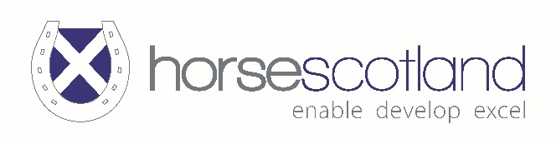
National Equestrian Nominees 2023
Club of the Year
Ravelrig Riding for the Disabled
Thornton Rose Riding for the Disabled
Moray and Nairn Pony Club
Dalnair Riding Stables
Woodend Riding Centre
NMW Riding Academy
Fife Pony Club
Tay Valley Chasers Racing Club
Equestrian Business of the Year
Auchlishie Eventing – James Helyer
Strathearn Eventing – Sarah Houlden
Paige H Equestrian Services - Paige Howarth
Susan Ritchie
Woodend Riding Centre
RD Veterinary Physiotherapy
Grange Saddlery - Holly Allan
Equestrian Employee of the Year
Polly Steele
Equestrian Photo of the Year
Martin Jones
Jamie Webster
Millie Boo Smith
Amanda Stewart
Equestrian Writer of the Year
Lucy Blain
Equine Breeder of the Year
Ian Young
Sandra Low-Mitchell
MFS Stud
Owner of the Year
Cameron Crawford
Debbie Whalley
Harry Payne
Shona Leckie
Una McLean
David Andrew
Participation Coach of the Year
Lorraine Buchan
Jo Newens
Jennifer McNeish
Wills Oakden and Daniel Scott
Lee-Anne Bryson
Karen Dewar
Lorraine Grant
Debbie Lush
Sarah Houlden
Kayreen Jones
Claire Marshall
Alex Fox McKinnon
Performance Coach of the Year
Liz Daniels
Sarah Houlden
Performer of the Year
Jade Paterson
Wills Oakden
James Smith
Youth Performer of the Year
Imogen Casely
Rowan Lee
Millie Boo Smith
Sandy McLean
Grace Botterell
Project of the Year
Scottish Racing Academy
Equi-Scotia
Volunteer of the Year
Anna Kozicki
Lyera Xin Yin Lye
Kerry Sutherland
Marian Lamb
Youth Coach of the Year
Ellie Watt
Youth Volunteer of the Year
Lottie LeJeune
Millie Boo Smith
Young People’s Coach of the Year
Rebecca Black
Pauline Saddler
Emma Sayer
Team of the Year
Scottish Racing Academy
Spur Sisters - – U21 Dressage Team

